Name: Class: Date:

NATURAL SELECTION

**Introduction**

**Charles Darwin** (1809 – 1882) was an English naturalist who first developed a theory of evolution that has laid the groundwork for modern biological thinking. Darwin grew up in a time when the scientific view of the natural world was dramatically shifting. Geologists were suggesting that Earth was more ancient than previously thought and had changed over time. Biologists were suggesting that life on Earth was also changing. In this climate, Darwin developed a scientific theory of evolution that explains how modern organisms evolved over long periods of time through **descent from common ancestors**.

**Darwin’s Fateful Journey**

In the year 1831 and at the age of 22, Charles Darwin joined a 5-year trip around the world as the official naturalist on the ship **H.M.S. Beagle**. The main purpose of the Beagle’s voyage was to map the coastline of South America. The ship traveled around the coast of South America to the Galapagos Islands. From there, the ship pursued a westerly course passing the southern coast of Australia, then going north to the southern coast of Asia, and then south along the southern coast of Africa back to England.

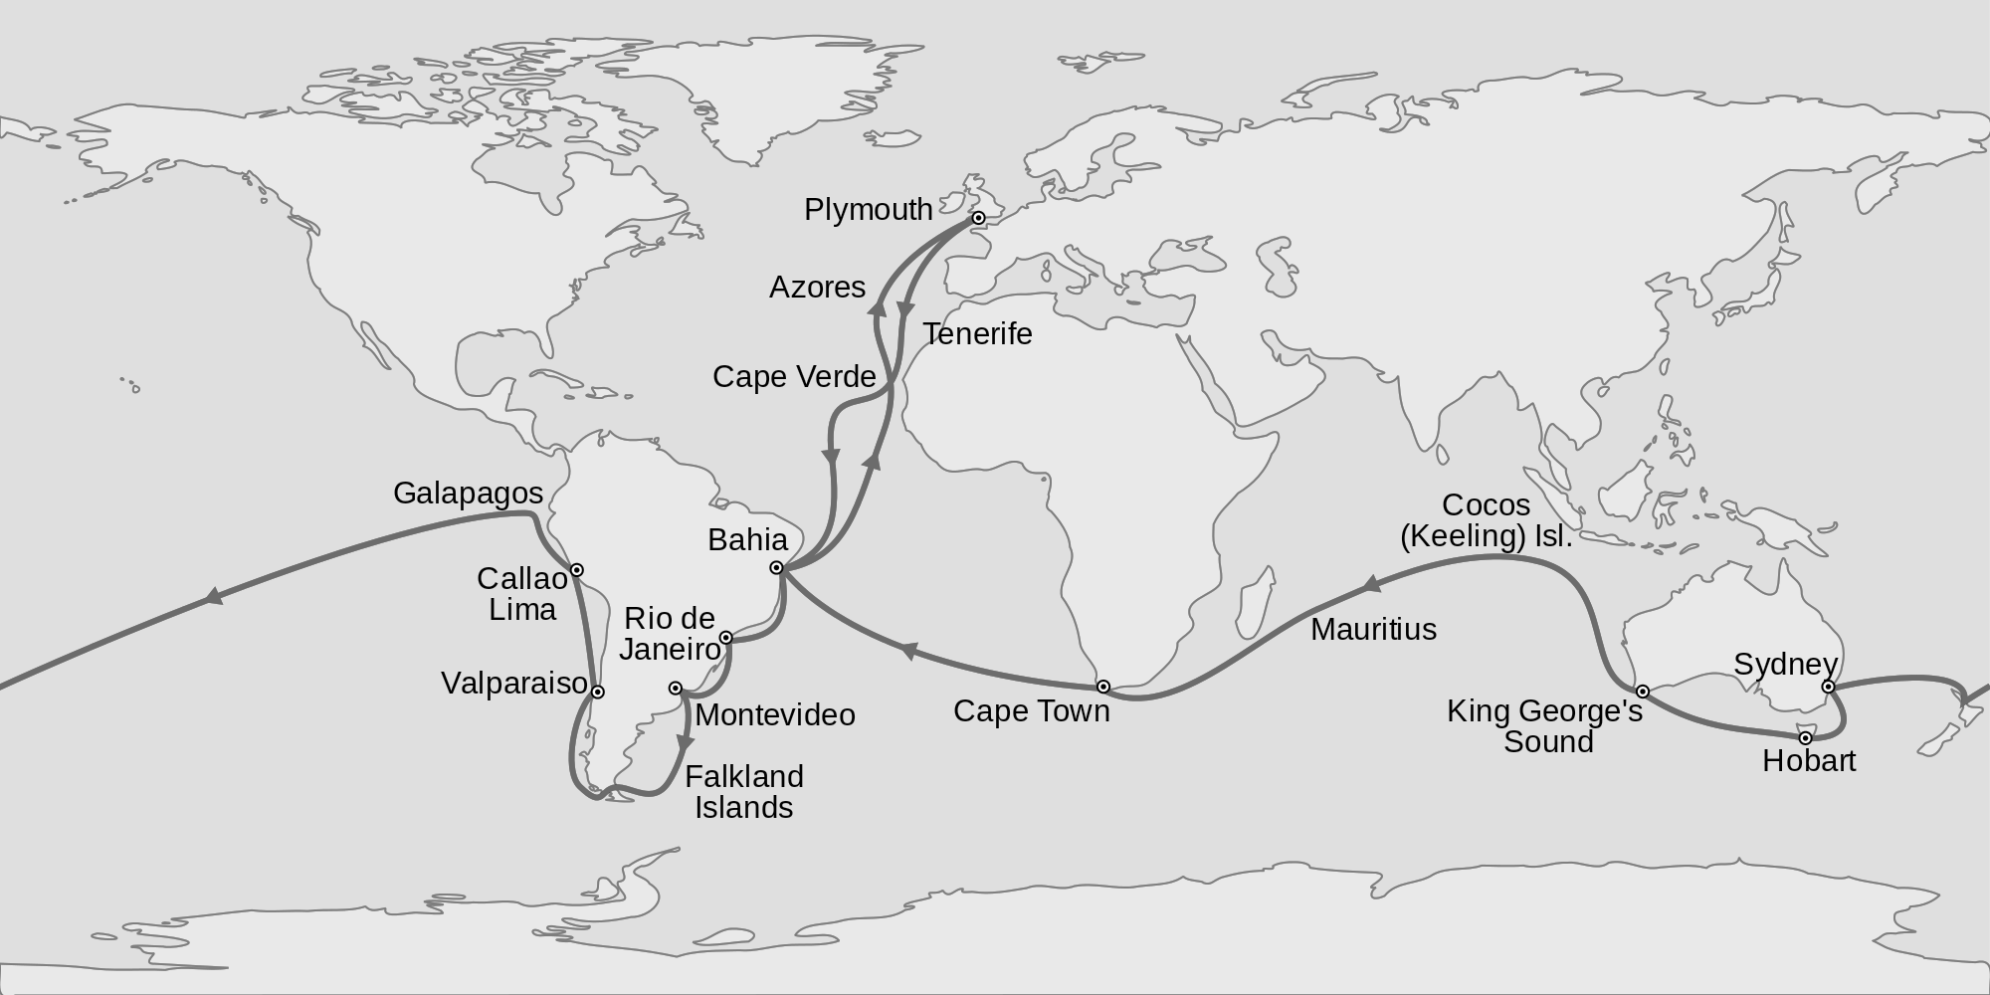

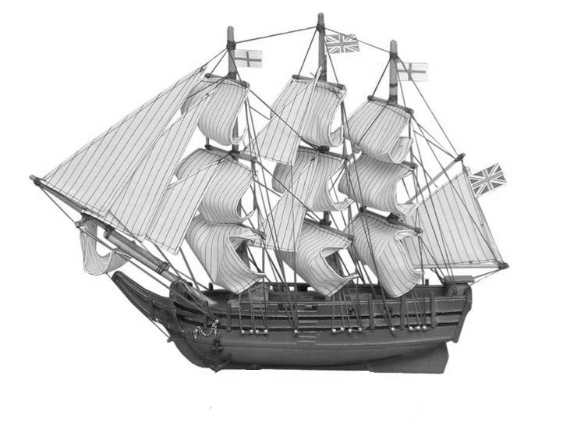

Darwin role was to collect specimens of plants and animals and make observations about what he saw. No one knew it at the time, but this journey would become one of the most important scientific voyages in history because it led Darwin to develop his ideas about evolution.

**What Darwin Observed Aboard the Beagle**

Darwin filled his notebooks with observations about the characteristics and habitats of the different species that he saw. But Darwin wasn’t content just to describe the biological diversity that he saw: he wanted to explain it in a scientific way. Darwin looked for larger patterns in his data, and as he traveled, he noticed three major patterns of biological diversity (see table on the following page).

As an example, on the Galapagos islands, a collection of closely-spaced islands off the coast of Ecuador, Darwin observed that one type of bird, a **finch**, lived on all of the islands. However, finches living on each island had slightly different beaks. On one island, they finches had heavy beaks. These finches primarily ate heavy seeds that they cracked open with their strong beaks. On another island, the finches had thinner, sharper beaks. These finches probed local plants for small insects. After careful study, Darwin concluded that the finches’ beaks had adapted to the type of food available on each island.

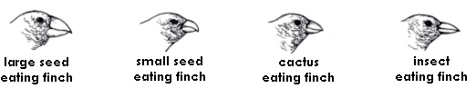

**Darwin’s Observed Patterns of Biological Diversity**

|  |  |  |  |
| --- | --- | --- | --- |
|  | **Species Varied Globally** | **Species Vary Locally** | **Species Vary Over Time** |
| **Observation** | Darwin observed that different, yet ecologically similar, animal species inhabited separate, but similar, habitats worldwide. | Darwin observed that different, yet related, animal species occupied different habitats within a local area. | Darwin observed that some fossils of extinct animals were very similar to the skeletons of living species. |
| **Example** | Darwin found flightless, ground-dwelling birds on different continents: ostriches in Africa, rheas in South America, emu and cassowaries in Australia. | Darwin saw that among giant tortoises in the Galapagos islands, which are all related, shell shape corresponded to different habitats and food type. | Darwin unearthed fossils of a long-extinct Glyptodon – a giant armored animal. Living in the same area was a similar armored animal, the armadillo. |
| **Diagram** |  |  |  |

**The Struggle and the Race to Publish**

For the next 25 years, Darwin studied and organized his extensive notes and specimens. Within the first 5 years, Darwin had worked out the main points of his **theory of natural selection**. Many of his scientific friends considered Darwin’s ideas to be brilliant and urged him to publish them. Although Darwin wrote a complete draft of his ideas, he didn’t publish for another 20 years. Why?

Darwin knew that many scientists, including some of Darwin’s teachers and colleagues, had ridiculed the ideas of the French biologist **Jean-Baptiste Lamarck’s**. Lamarck’s theory of evolution proposed that helpful adaptations developed *within* an organism’s lifetime as they were used more and more. In addition, Lamarck proposed that organisms evolved in a straight line fashion from “less perfect” to “more perfect”. Both ideas were later proven to be incorrect. Still, Darwin felt that his own theory was just as radical as Lamarck’s. Darwin wanted to gather as much evidence as he possibly could to support his ideas before making them public.

Meanwhile, Darwin’s cousin, **Alfred Russell Wallace** (1823 – 1915) had independently begun writing a book based on ideas very similar to Darwin’s using his observations of species in Southeast Asia. In 1858, Wallace presented his early manuscript to his cousin for review. At this point, Darwin realized that he needed to publish his own work immediately or his theory would be overshadowed by Wallace’s. In 1859, Darwin published *On the Origin of Species by Means of Natural Selection, or the Preservation of Favored Races in the Struggle for Life.* Today, this book is referred to by a shorter title, ***The Origin of Species****.* In this famous book, Darwin’s theory of natural selection was clarified.

**Darwin’s Theory of Natural Selection**

Darwin’s did not invent the idea of evolution – that had been described multiple times by multiple individuals in history. Darwin’s great contribution was to describe a process in nature – **a scientific mechanism** – that could explain how evolution occurred. **Natural selection** is the name of this process.

Darwin’s theory of natural selection can be summed up simply: large numbers of new plants and animals are produced by nature. Many of these do not survive because nature “weeds out” weak and feeble organisms by killing off those that cannot adapt to the local environmental conditions. Only the strongest and most efficient survive and **produce offspring**, which carry on the traits of their parents. These traits become more common in the general population. Darwin created four specific tenets, or **postulates**, for his theory, which are listed in the following table.

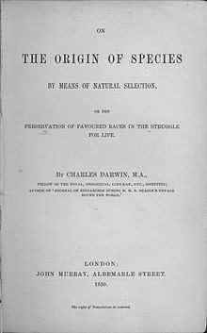

|  |  |
| --- | --- |
| **Postulate** | **Description** |
| **Overproduction** | Every organism produces more offspring than can possible survive. |
| **Variation** | Individuals of the same species have natural variations in their genetic traits. Some of these variations give an individual an advantage – increasing their chance of surviving and reproducing. These advantageous traits are called adaptations. |
| **Competition** | Not all offspring survive. There is competition between organisms for the necessities of life: food, water, living space, mates, etc. This means that there is a struggle for existence, where some organisms die and more hardy organisms survive. |
| **Selection** | Individuals with more helpful adaptations have more “fitness”. Fitness describes how well an organism can survive and and reproduce. In this case, the environment is the selecting agent as it determines which traits are better for survival and which are not. |

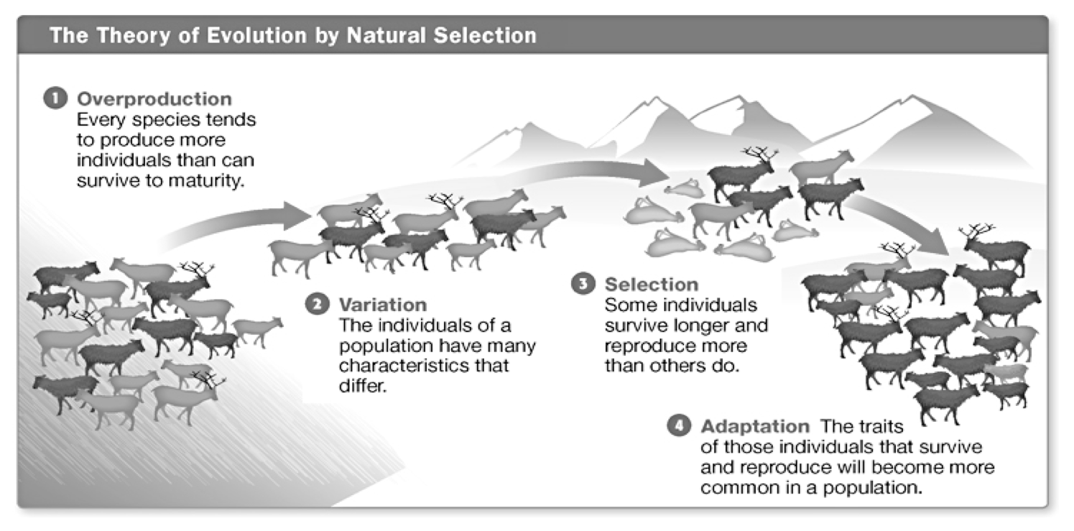

**Natural Selection Leads to Evolution**

**Natural selection is the process where individuals in a population that possess better adaptations survive and reproduce more than other individuals of the same population. This is not technically evolution. Evolution is loosely defined as the gradual change of a species over time. In other words, natural selection concerns individual organisms, whereas evolution concerns an entire species.**

**Natural selection leads to evolution since the traits of those individuals who are able to reproduce influence the traits of future generations. Over time, these advantageous traits become more common in a species, which causes the species to evolve.** For example, if a population of camouflaged brown rabbits survive and reproduce more than non-camouflaged white rabbits, then by way of natural selection, the dominant brown-fur trait will increase with future generations. Slowly, the species of rabbit will evolve to have mostly brown fur.

REVIEW QUESTIONS - NATURAL SELECTION

1. How did Darwin’s voyage on the Beagle give him an advantage over his fellow naturalists at home?

|  |
| --- |
|  |
|  |
|  |

1. The small finches on the Galapagos islands lived on islands with slightly different habitats. How did these varied habitats affect the evolution of the finches on different islands?

|  |
| --- |
|  |
|  |
|  |
|  |

1. What is an adaptation? Give three examples of adaptations.

|  |
| --- |
|  |
|  |
|  |

1. Describe Darwin’s four postulates for natural selection by filling in the summary table below.

|  |  |
| --- | --- |
| **Postulate** | **Description** |
| **Overproduction** |  |
|  | Individuals of the same species have natural variations in their genetic traits. Some of these variations give an individual an advantage – increasing their chance of surviving and reproducing. |
| **Competition** |  |
| **Selection** |  |

1. Natural selection is *not* evolution, but rather a scientific mechanism for it. What is evolution and how can natural selection cause a species to evolve?

|  |
| --- |
|  |
|  |
|  |
|  |
|  |

Name:

# GREGOR MENDEL- early life

Gregor Mendel was born on July 22nd, 1822, in Heinzendorf, Austria. Growing up was a hardship; his parents were farmers and did not have a lot of money. Mendel decided to join a monastery in order to find a better life for himself, though he never forgot the farming skills his parents taught him.

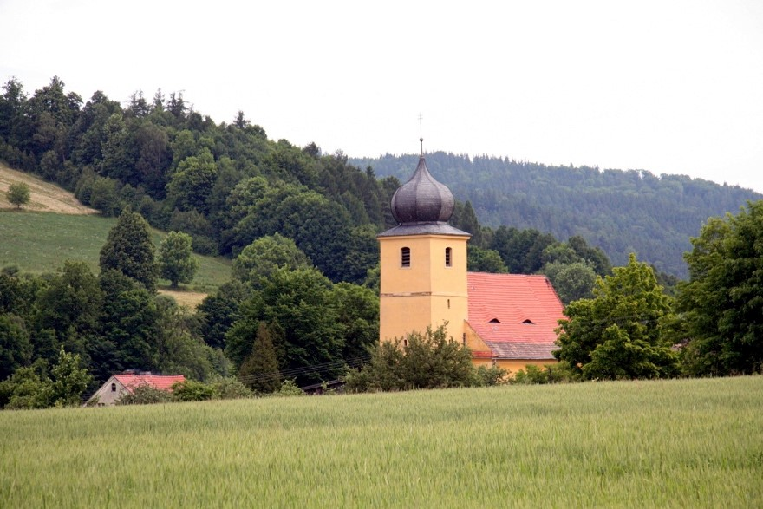

Björn Ehrlich, 2008

## Gregor Mendel at the University of Vienna

Mendel attended the University of Vienna to acquire an education. It was there that Mendel was introduced to a biologist by the name of Frank Unger. Mendel was impressed with Unger because he had a practical view of inheritance, rather than the traditional (and widely-accepted) spiritual view. This sparked Mendel’s curiosity.

Mendel, growing up on a farm, had a background in botany and wanted to experiment with Unger's ideas using plants. He had to ask to do this very carefully, though, because usually monks were not allowed to study or teach biology. It took about two years until Mendel finally began experimenting with variation, heredity and evolution in plants. He chose to study in detail the common garden pea, which he grew in the monastery garden.

# GREGOR MENDEL- experiments in the monastery gardens

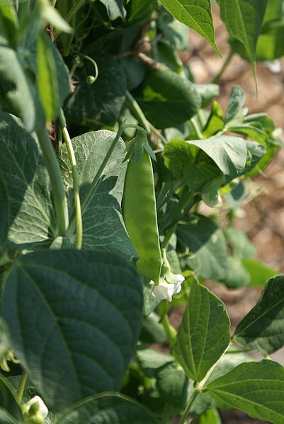

## Mendel's Experiments

Between 1856 and 1863 Mendel grew, cared for, and tested nearly 30,000 pea plants. In doing this, he paid special attention to seven traits such as: shape of seed, color of seed, tall stemmed and shortstemmed plants, flower color, pod shape and pod color. Mendel worked on this for several years, carefully self-pollinating the pea plants, as well as covering each individual plant to prevent accidental pollination by insects.

Mendel collected the seeds produced by the plants and studied the offspring of these seeds by observing that some plants bred true and others not. For

example, Mendel discovered that by crossing tall and short parent plants he got hybrid offspring that resembled the tall parent rather than being a medium height hybrid. The plants expressed dominant or recessive characteristics.

Mendel’s work made way for present day genetics. The patterns of inheritance of various traits that he discovered lead to two generalizations that became known as the laws of heredity, they are: dominance, for a trait that shows up in an offspring; and recessiveness for a trait masked by a dominant gene.

# GREGOR MENDEL- scientific conclusions

## Mendel's Conclusions

**I**n 1866 Mendel published his findings on heredity in the ***Journal of the Bruno Natural History Society***. Unfortunately, his publication t had absolutely no impact on the scientific world (at least in 1866). Mendel’s findings were too complex, even by the most influential scientists did not understand his work! He did make some attempt to contact scientists in other countries, by work but because he was an unknown monk, no one seemed to care. Two years after Mendel had published his paper he was elected abbot of the monastery.

His work collected dust for about 34 years before anyone reviewed it. Mendel died in 1884.

## Mendel Rediscovered

In the early 1920s and early 1930s the full significance of Mendel’s work was finally recognized –and specifically used to gain an understanding of the evolution. All because of Mendel’s years of research in population genetics, investigators were able to demonstrate that Darwin’s theory of evolution could be described in terms of the change in gene frequency in a population over successive generations.

Name: ________________________________ Date: _______________ Per ____

# GREGOR MENDEL

*The Father of Genetics*

## Mendel's Early Life

1.Where and when was Gregor Mendel born?

2.What was his childhood like growing up?

3.What did Mendel decide to do in order to make his life better?

## The University of Vienna

1.Who influenced Gregor Mendel, and what were this person’s views on inheritance?

2.What did Mendel decide he wanted to do at the University?

3.What type of plants did Mendel use in his experiments, and where did he grow these plants?

## Mendel's Experiments

1.How many years did Mendel spend experimenting with inheritance patterns in the garden? (Also list the years he was there).

2.At least how many pea plants did Mendel care for over these years?

3.How many different pea traits did Mendel compare? What were some examples of these pairs?

4.Mendel self-pollinated many pea plants. What did he study about these plants after selfpollinating them?

5.If Mendel crossed a true-bred tall pea plant with a short pea plant, which trait would always show up in their offspring?

6.Which two terms did Mendel come up with, and what do they mean?

## Mendel's Conclusions

1.What YEAR and which journal did Mendel publish his experimental data in? What impact did this have in the scientific world?

2.Why did no one seem to care about his findings?

## Mendel Rediscovered

1.When did Mendel's work finally become recognized and appreciated?

2.Was Mendel alive to see this?

3.How were investigators able to link Darwin's theory (evolution) to Mendel's findings?

**KIDNEY DISEASE**

**What's the Deal With Dialysis?**

Don't you love swimming in a cool, blue pool? Splashing around in that clear water, floating like a lily pad, swimming like a shark. But imagine if the water wasn't clear or clean. What if it was filled with leaves, dirt, hair, and drowned bugs? Yeeech! You'd be one unhappy shark.

You'd probably want to clean it out before diving in. And you'd want to make sure the pool has a **filter** that removes the dirt, leaves, and other uninvited guests.

**The Kidneys and What They Do**

That's kind of what your kidneys do for you. Your kidneys are fist-sized organs, shaped like beans. They're below your ribs, toward the back.

When waste that's left over from breaking down food and your body's other activities naturally builds up in your blood, **your kidneys clean waste from your blood**. Then they mix the waste with a little water. That's what **urine is** — body waste mixed in water. The urine goes to your bladder, which you empty when you pee. Goodbye, waste!

**When Kidneys Don't Work Right**

In addition to removing wastes from your bloodstream, the kidneys also make and regulate hormones and other chemicals in your body. When the kidneys aren't working correctly, your body can develop several problems, including:

* Joint problems, body aches and pains, fatigue
* Bone problems, blood problems, skin problems, sleep problems

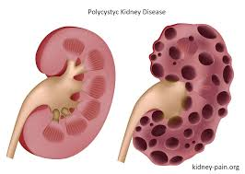

**What Is Dialysis?**

When someone's kidneys can no longer do their job and can't get better, a person has chronic kidney disease. A doctor might say the kidneys are failing. This means they are not working well and the person may need help. The person may be losing weight or feeling tired and sick.

A medical treatment called **dialysis** (say: dye-**al**-ih-sis) can take over the job of filtering your blood. Through dialysis, a person is hooked up to an artificial filtering system that removes waste from the blood. Not that many people younger than 19 receive dialysis — about 2,300 young people in the United States do.

**Reading Comprehension and Analysis Questions:**

**1) What do your kidneys look like?**

**2) Where are your kidneys located?**

**3) What do your kidneys do for your body?**

**4) What is urine?**

**5) What health issues could occur if your kidneys aren’t working well? (Name at least 4)**

**6) What is the treatment for kidney problems?**

**7) How does dialysis work? (3 sentences)**

**8) Which body system are the kidneys a part of?**

**9) What would happen to your blood and your body if you didn’t have kidneys to clean your blood?**